Question – 01

select Unique records from EMP Table.

Query:

SELECT DISTINCT * FROM [dbo].[hexaware_emp_batch02];

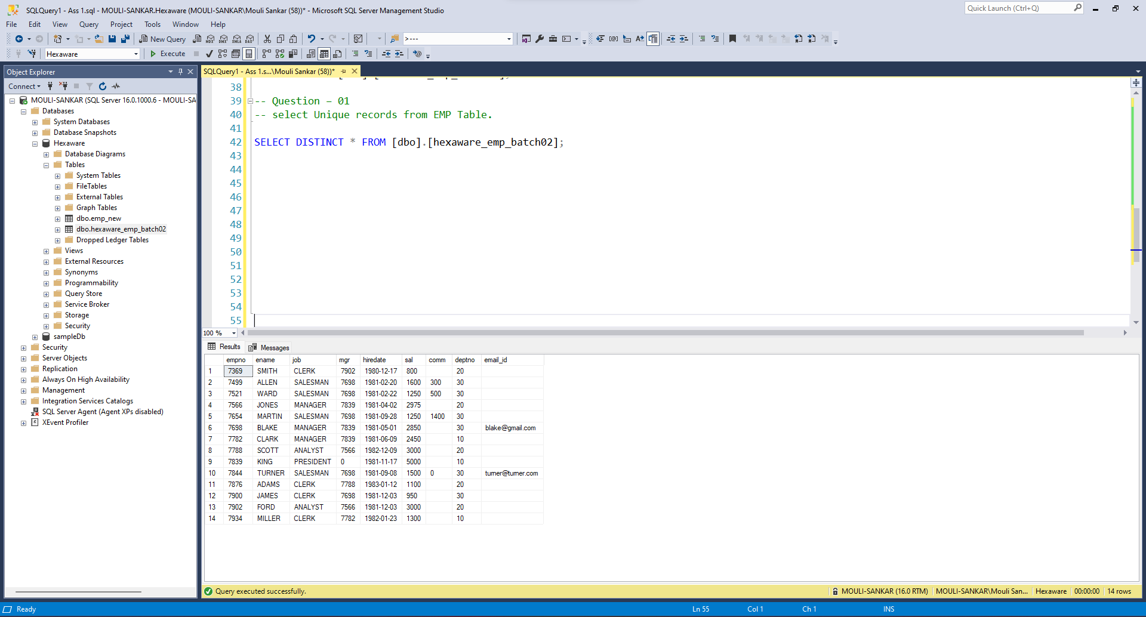

Question – 02

delete duplicate records from emp

(hint - using RowID and correlated sub-query).

Query :

WITH duplicate_remove AS(

SELECT

ROW_NUMBER() OVER (PARTITION BY ename ORDER BY empno) AS dup_values,

empno,

ename

FROM [dbo].[hexaware_emp_batch02])

delete from duplicate_remove

where dup_values > 1;

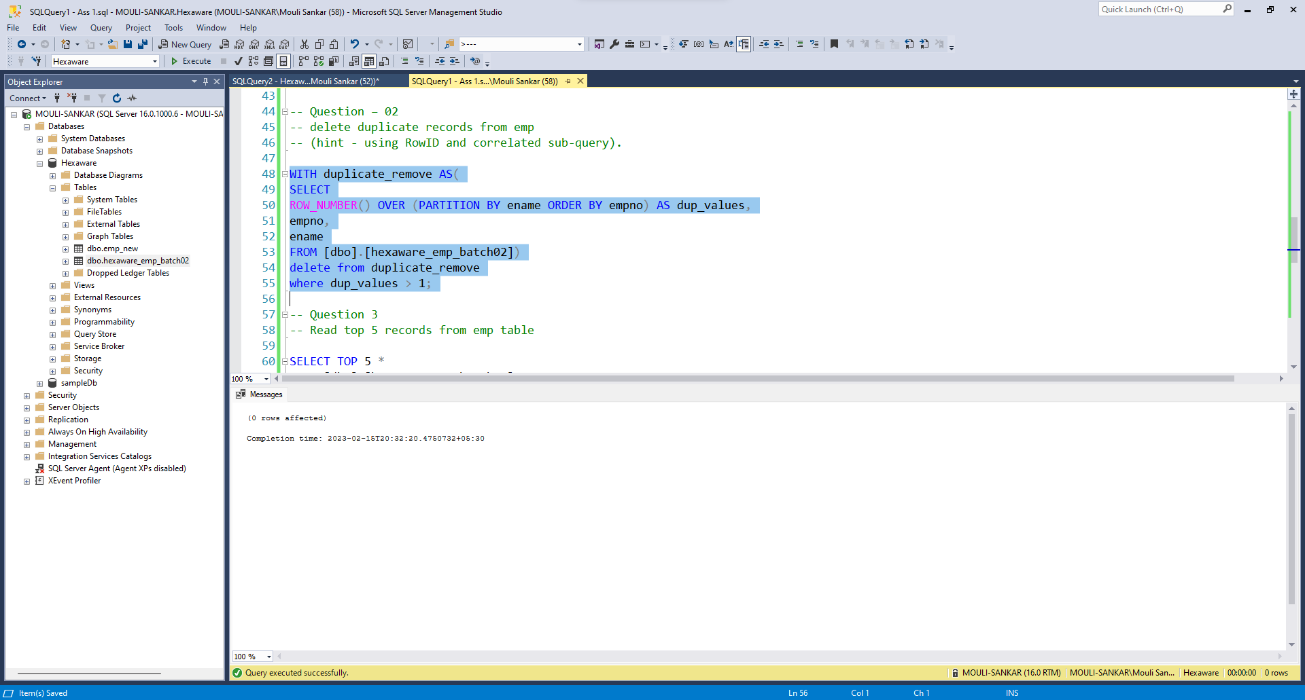

Question – 03

Read top 5 records from emp table

Query:

SELECT TOP 5 *

FROM [dbo].[hexaware_emp_batch02];

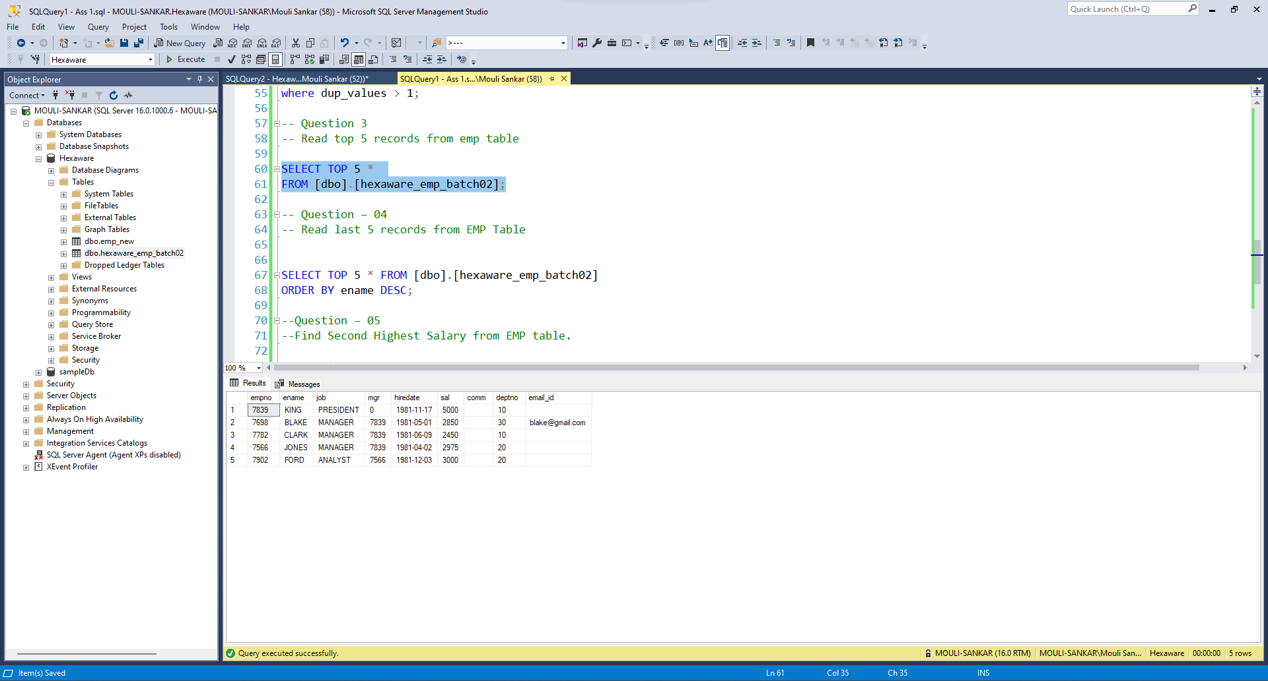

Question – 04

Read last 5 records from EMP Table

Query:

SELECT TOP 5 * FROM [dbo].[hexaware_emp_batch02]

ORDER BY ename DESC;

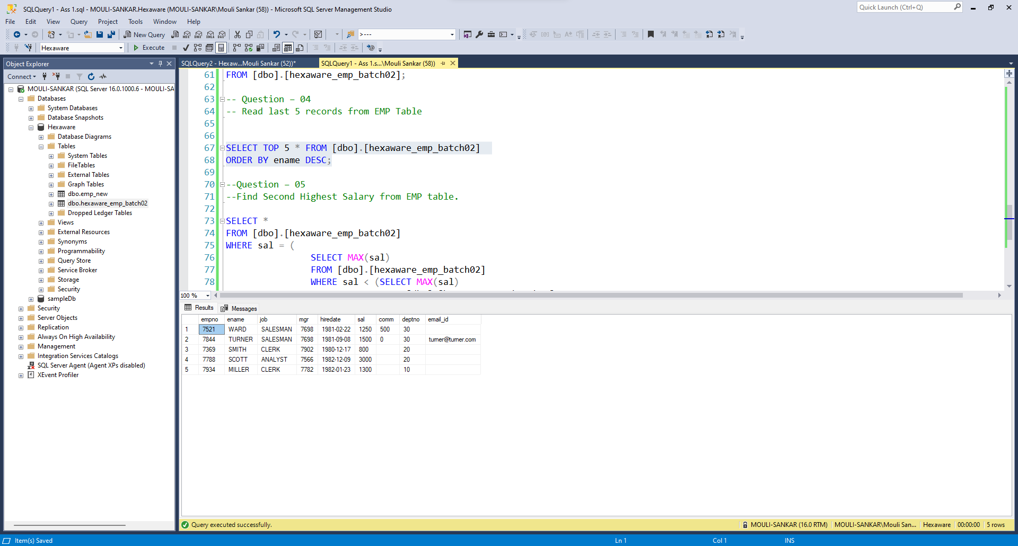

Question – 05

Find Second Highest Salary from EMP table.

Query:

SELECT *

FROM [dbo].[hexaware_emp_batch02]

WHERE sal = (

SELECT MAX(sal)

FROM [dbo].[hexaware_emp_batch02]

WHERE sal < (SELECT MAX(sal)

FROM [dbo].[hexaware_emp_batch02]

)

);

